ECN-104 Project Report
Braille translator on FPGA Board
Arush (19116011), Vamsi (19116082) , Karthik (19116031) and Naveen(19116033)

Abstract— Our project is to design a braille translator for FPGA board using Verilog Hardware programming. It converts 6-bit Braille input to give corresponding ASCII values of the characters.

Introduction
As the world grows in the amount of information available to us, it is also our responsibility to ensure that it is also accessible to the maximum number of people possible. Of the 7.8 billion people inhabiting this Earth (as of March 2020), approximately 285 million people are estimated to be visually impaired, of whom 39 million are blind.
Among many technologies to assist and allow people suffering from visual impairments, Braille is one of the most popular and widely used methods. This project aims to enable translation of Braille input into ASCII, so as to enhance the accessibility for the visually impaired.

Architecture of the design
The design involves the following:-
One module converts the braille input to a binary coded decimal of it’s ASCII value.
Another module sends the binary value to use in the seven segment display.
An overall module, which converts converts braille to ASCII values shown as two digits on 7 segment displays using the previous modules.

Challenges faced during implementation

Evaluation of expressions required the use of online Karnaugh maps, which was otherwise a very tedious task. We also faced several problems while debugging and writing the code. Bad network conditions bogged down the productivity of the team, while one member didn’t have access to a laptop, overall leading to an increased workload.

Simulation results
Describe the simulation framework, main design and testbench
- Table Type Styles
Table Head | Table Column Head
 | Table column subhead | Subhead | Subhead
copy | More table copyª
a. Sample of a table footnote. (table footnote)

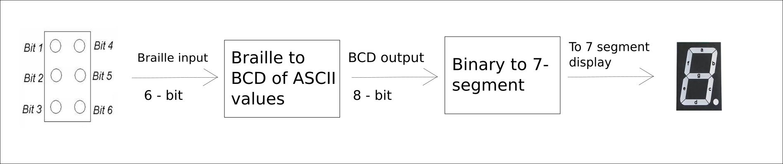
- Flow chart of design
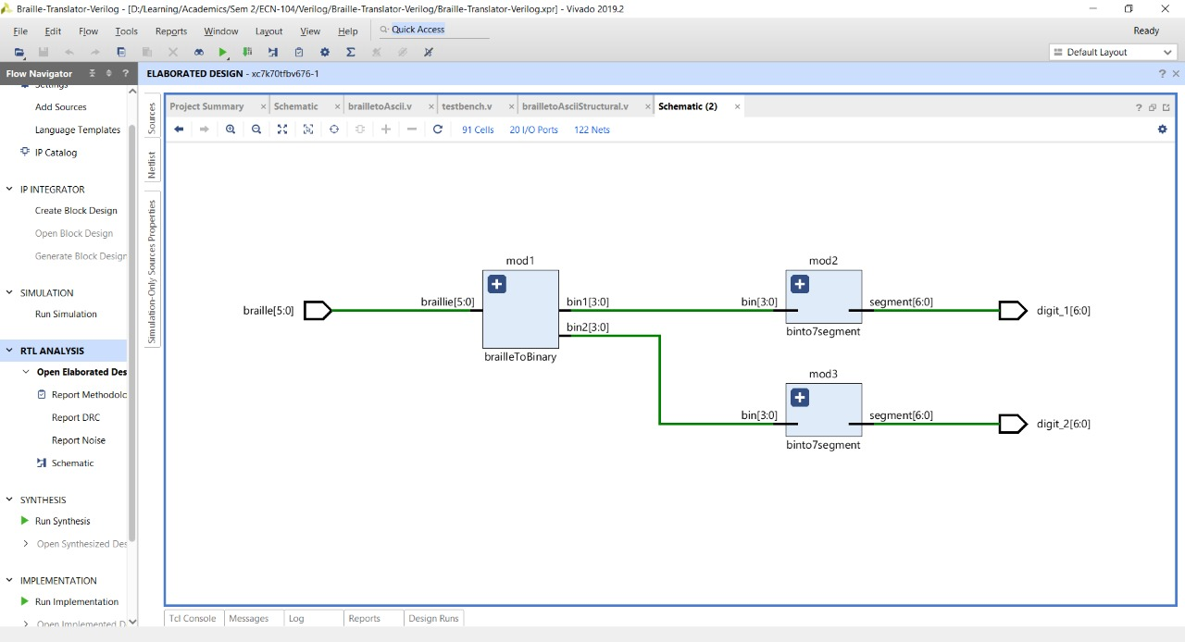
Fig. 2. Architecture of design

Conclusions
Hence we have designed a translator which translates Braille into ASCII and displays it using a 7 segment display

References
[1] Mano, M. Morris, 1927- “Digital design : With an Introduction to the Verilog HDL” / M. Morris Mano, Michael D. Ciletti.—5th ed.
[2] Pascolini D, Mariotti SPM. Global estimates of visual impairment: 2010. British Journal Ophthalmology Online First published December 1, 2011 as 10.1136/bjophthalmol-2011-300539.

